Simulation 1

1.

2.

//set to higher frequency 4000

3.

Set to 4000

4.

Set to around 4000 frequency

Simulation 2

300 rpm reference speed

Frequency = 10.8711

RMS value = 58.6653

900 rpm reference speed

Frequency = 31.9623

RMS value = 154.1192

1200 rpm reference speed

Frequency = 53.7466

RMS value = 230.0347

Add more points 150-15000

2.

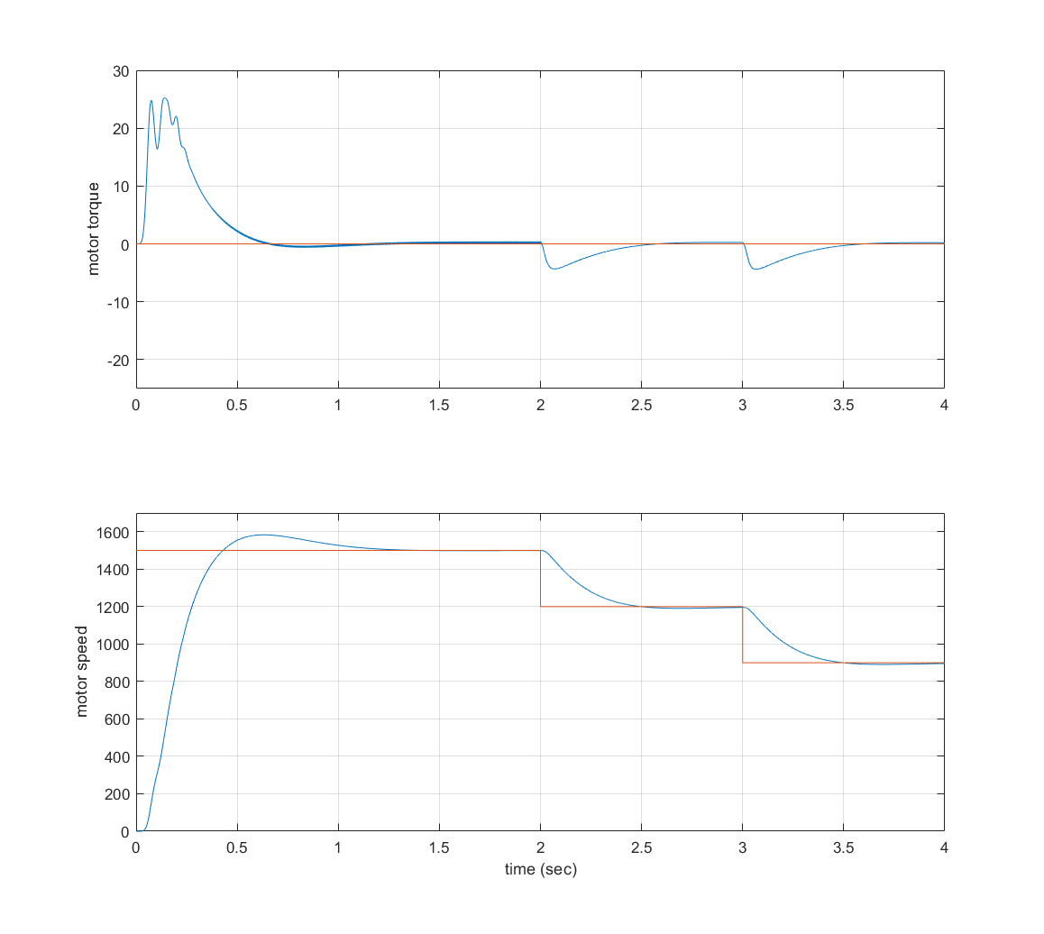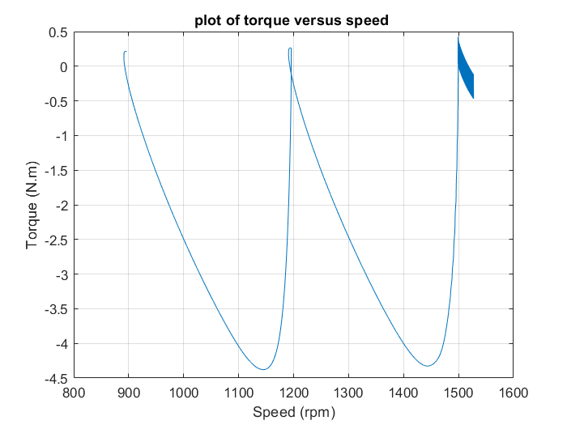

3.

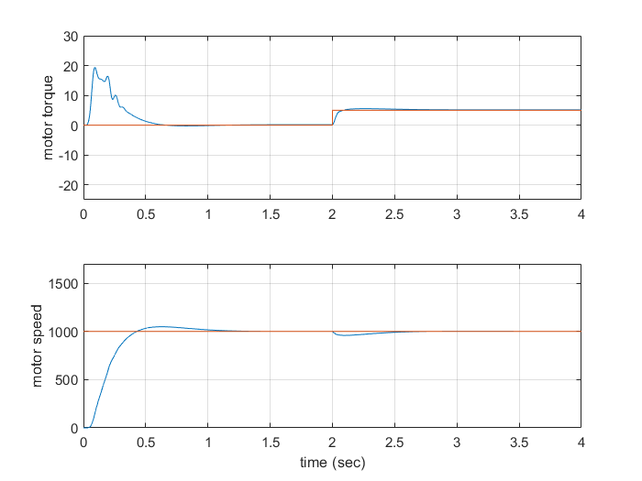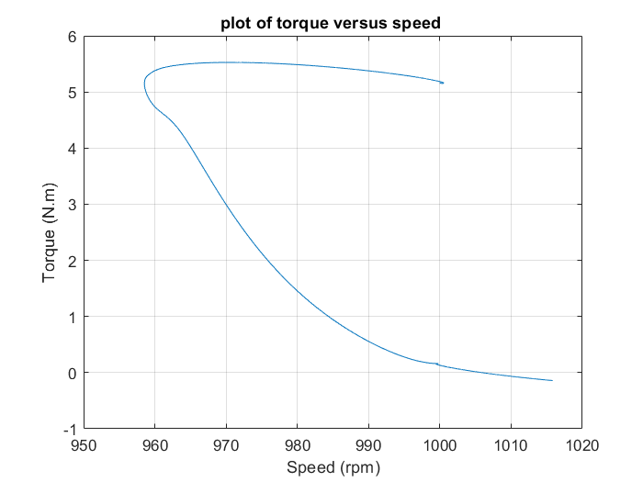

Experiment

-0.1N: 1270